The Articles of Confederation
After the Revolutionary War ended, the Second Continental Congress needed to decide what to do with the existing colonies that had now separated from England. Should the colonies be 13 different countries? Should they be grouped into several countries, each made up of multiple colonies? Should they all be one country?
Here's what they were afraid of:
- They didn't want anything remotely similar to what already happened with
England happening again (no king or tyrant in control of them)
- A national government without vet)/ limited power might challenge or take away the very rights they had just fought for
What resulted was the Articles of Confederation. Under this new plan, the colonies would neither be separate states nor a union, they would be a "league of friendship" in which each colony remained a separate entity (more like being its own country) but cooperated with the other colonies for common purposes (more like being a union).
Here's how it worked:
- Each state was like its own country, handling most matters concerning its citizens on its own
- On matters that concerned the whole group, each state got one vote
- order to approve a new law, 9 out of 13 states needed to vote "yes'
- In order to make a change to the Articles (an amendment), all 13 states needed to vote "yes'
- There was no president or leader of the Confederation There was no national court system
The Federal Government COULD:
- Deal with foreign affairs (matters with other countries)
- Establish weights and measures Declare war or peace
- Raise an army
- Print money
- Make treaties
- Set up a postal system
The Federal Government COULD NOT:
- Regulate trade (between the states or between states and foreign countries) Impose taxes
- Settle disputes among the states
Problems with the Articles of Confederation:
- The central government was weak (ineffective)
- Congress had no power to tax citizens - they could only make REQUESTS for money from the states
- Congress had no power to collect state debts owed to the federal government
- Currency had no backing (this led to inflation)
- Because all states made their own money, trade between states was difficult
- Foreign nations didn't want to deal with this "new" America
Questions that led to the Articles
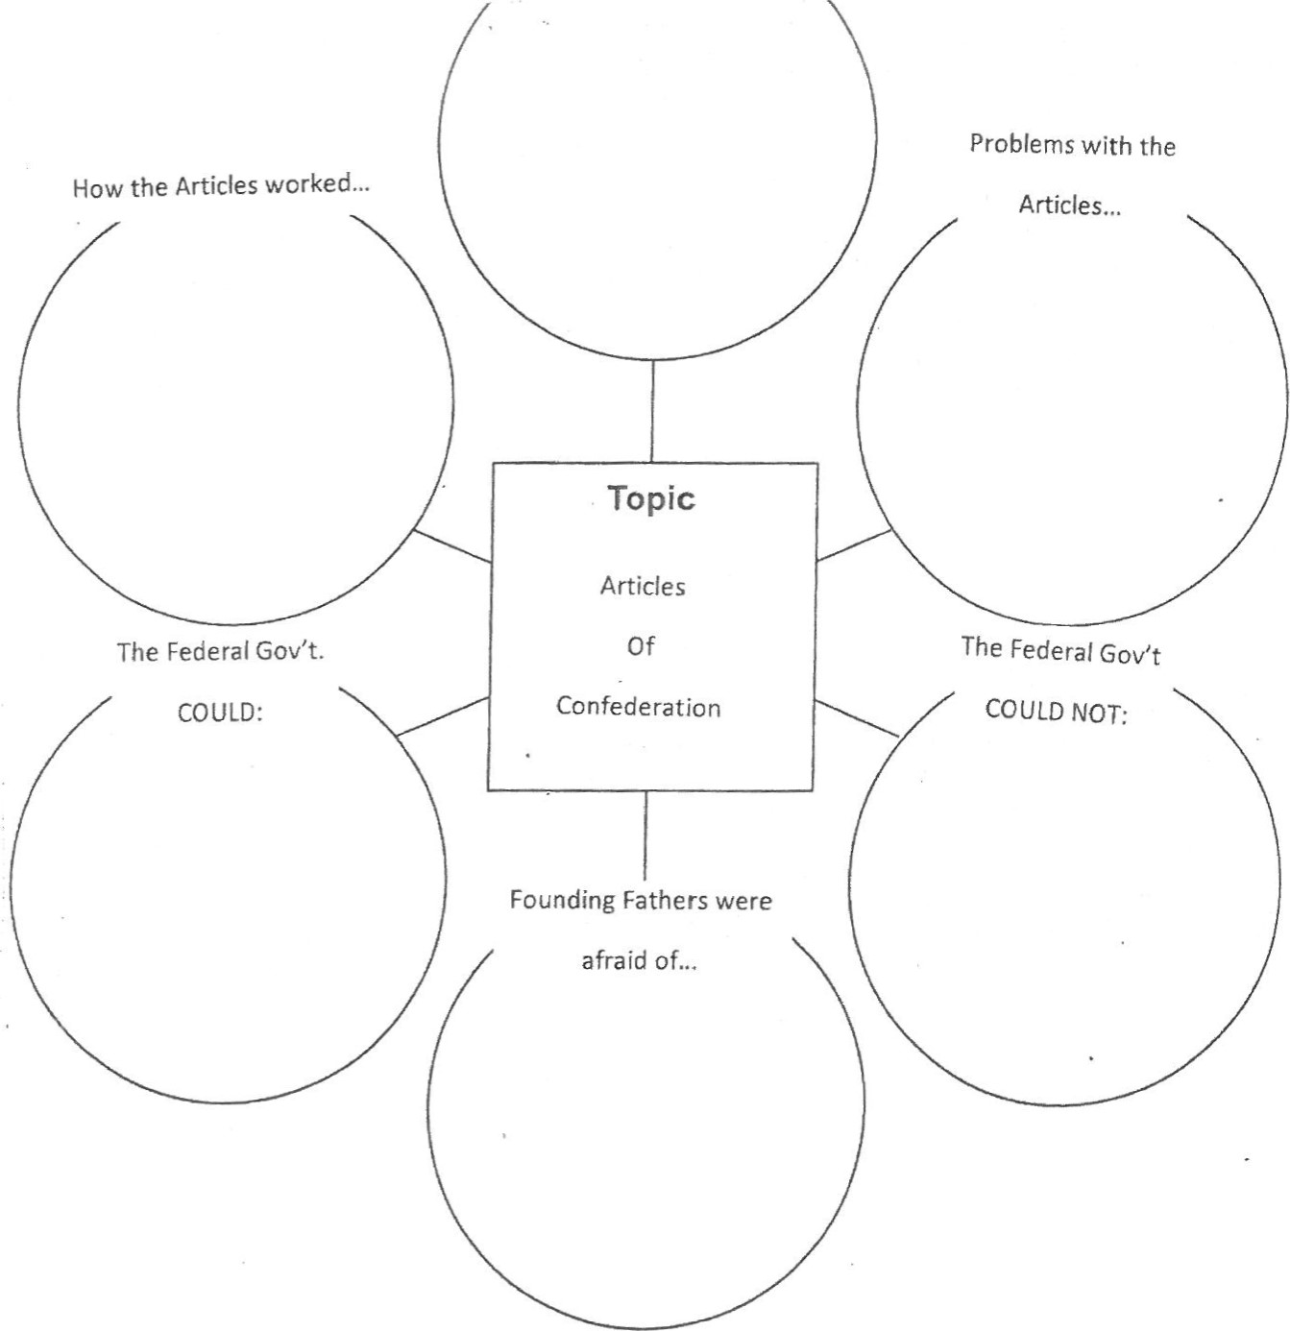The Federal Gov't. The Federat Gov't
of
Confederation

