Lawsuit over Kentucky driver’s ‘IM GOD’ license plate will go forward
(Fredrick Kunkle, The Washington Post, April 5, 2018)
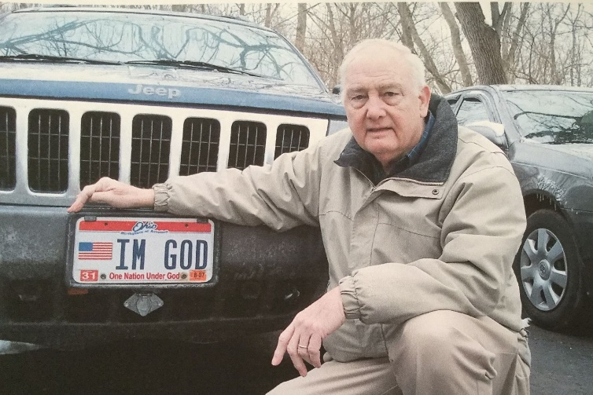
God is a retired postal worker who lives in Kentucky and drives a Jeep.

At least that is what Ben Hart’s old license plate says, the one he used in Ohio before he moved to the Bluegrass State.
Now Kentucky will not let him use “IM GOD” on a vanity plate, so Hart has sought relief in a lower court of judgment. After a two-year wait, it looks as if his case can proceed to trial.

Hart, who has been an atheist since he was 15, asked Kentucky’s Motor Vehicle Licensing agency in 2016 for a vanity plate that says, “IM GOD.” It was the message he had used on his license plate in Ohio for 12 years or so until he moved south of the Ohio River.

Kentucky officials refused. The licensing agency — whose regular license plate options include one proclaiming “In God We Trust” — deemed Hart’s message “vulgar or obscene.” When challenged by the Freedom From Religion Foundation, the agency said the message was lacking “in good taste and would create the potential of distraction to other drivers and possibly confrontations.”
In November 2016, the ACLU filed a lawsuit on Hart’s behalf, arguing that Kentucky had violated his First Amendment rights. On Friday, U.S. District Court Judge Gregory F. Van Tatenhove’s ruled the case can move forward, the Lexington Herald reported.
It is not the first time, and probably will not be the last, courts have been asked to referee what is acceptable on a vanity plate.

Vanity plates have been around since 1931, when Pennsylvania introduced them, according to an article in the Wisconsin State Journal about their history. Courts have generally held that states may also place restrictions on the messages that go on license plates, so long as those restrictions are viewpoint-neutral.

Maryland’s Court of Appeals decided in 2016 it did not matter if the obscenity was in a language other than English, upholding the Motor Vehicle Administration’s decision to revoke a vanity plate that contained a naughty Spanish word. Yet New Hampshire’s highest court has ruled the state violated a man’s First Amendment rights by rejecting his application for a license plate saying, “COPSLIE,” local media reported.

In 2015, the U.S. Supreme Court decided a related case involving specialty license plates sponsored by private organizations. The court, in a 5-to-4 split, held that Texas could deny a request by the Sons of Confederate Veterans for a special license plate displaying the Confederate battle flag. The court said such specialty plates are a form of “government speech” that has been sanctioned by the state with limited private input — a finding dissenters criticized for taking “a large and painful bite out of the First Amendment.”

Outside the courtroom in Kentucky, Hart’s vanity plate has not created too much of a fuss, he said. The only incident he can recall occurred some time ago when another traveler called him out at an RV park in Texas. He said the woman came right up to him and declared, “Well, you’re not God.”

“And I said, ‘Well, I tell you what. I’ve got a hundred-dollar bill I’ve been carrying for 20 years for the first person that can prove I’m not God. Now go right ahead,’ ” Hart recalled. “She stammered for a minute, and she said, ‘Well, I can’t prove it, but I know you’re not God.’ And I said, ‘Well, I’ll keep my $100 then.’ ”

It is an argument he made in legal papers, too.

Hart, 78, said in an interview he became an atheist while he was still a teenager and waiting outside a church for the woman who would become his wife. The more he thought about Noah’s Ark and the Bible story about God literally pouring down his wrath on the human race, the more he decided he was a nonbeliever.

“I says, ‘What kind of God would drown every baby in the world?’ You know, that’s not somebody you worship,” Hart said.

It might be a federal case now, but that has not stopped Hart from using his provocative license plate anyway. He said it is okay to run Kentucky roads with only one official license plate mounted on the rear of a vehicle, so Hart has had “IM GOD” on the front of his Jeep for a while now. Whatever the courts rule, Hart also said his best defense is the license plate message happens to be accurate.

“The claim that I’m God is true because, according to the American Heritage dictionary, there are six definitions for God,” Hart said. “And No. 5 is ‘a very handsome man.’ And my wife says I’m a very handsome man, and nobody argues with my wife.”

