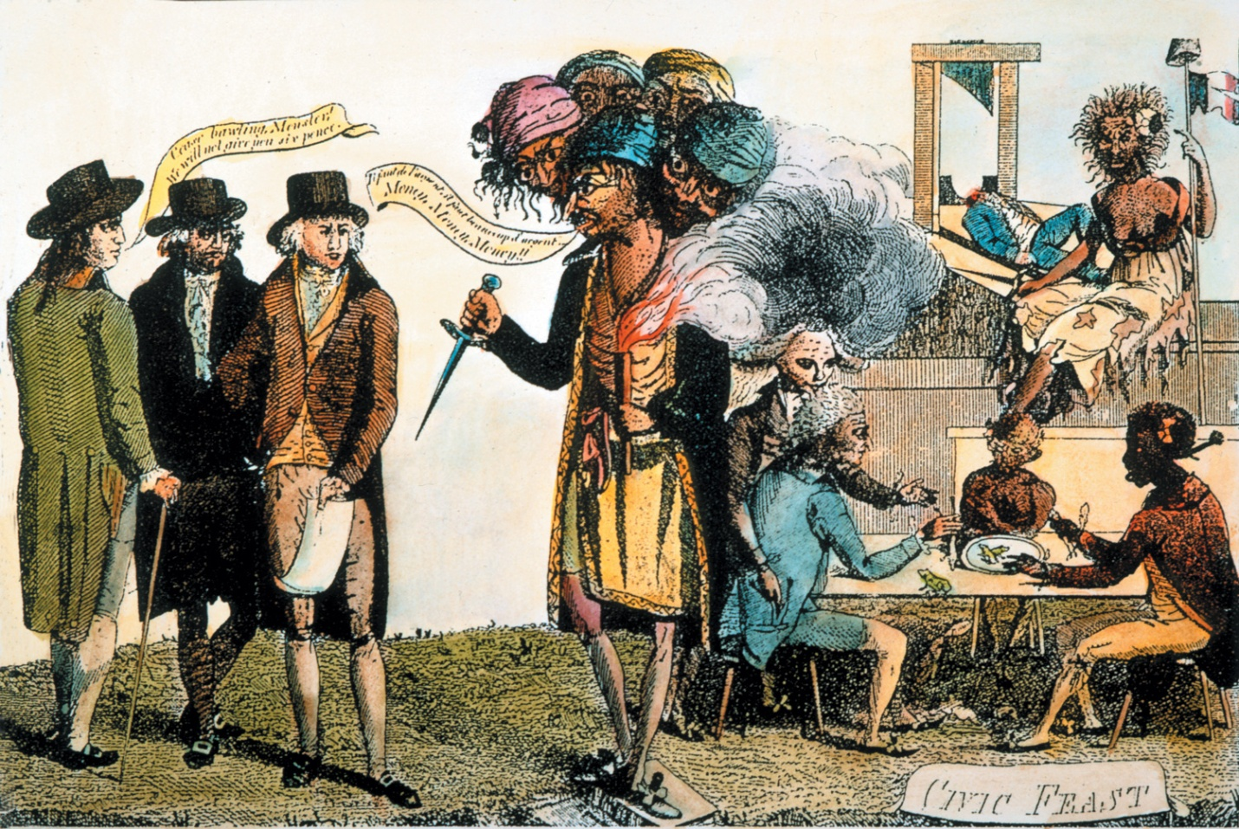
Image for “Protecting American Ships” (Adams)

