“Manifest Destiny” (resources for pre-reading activity)

“Common Sense” definitions
- “Manifest” – obvious
- “Destiny” – fate; meant-to-be

Artwork

Cartoon
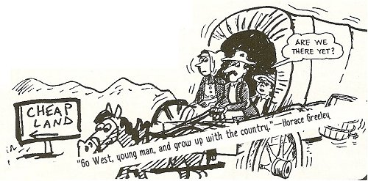
Two short videos:
(Video #1)
https://youtu.be/Bs2w4lwQRtc
(video #2)
https://youtu.be/Qrjg9ulR-xo

