Bill of Rights – political cartoons

- “Liberty vs. Order”

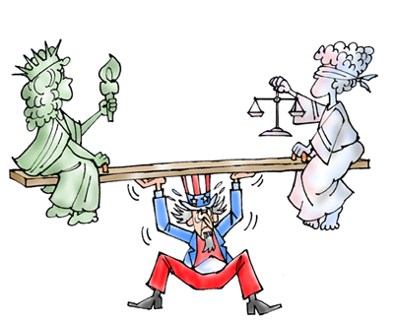

- “Double Image”

